## **Project “Divided” 1.5-Page GDD**

*Diablo/POE set in modern day*

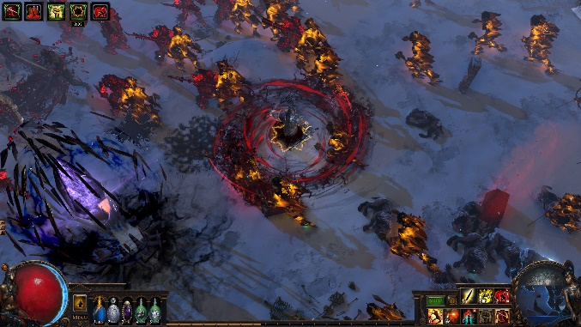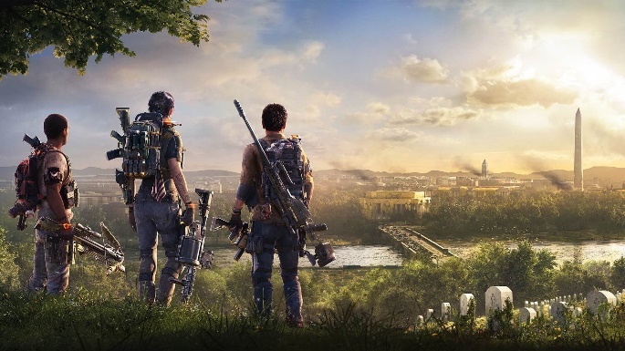

**Genre:** 3rd ARPG, single player, fixed camera  
**Target Audience:** 13+ old school RPG

**Controls:** mouse and keyboard

**Thematic Setting:** present day alternative universe

**Tech Stack:** unity 2018.3, audacity, asset store art 3d and UI

**Platform(s):** steam

**MVP Game Moment:** simple dungeon crawler with basic combat with multiple weapon and spell types

**Game Summary:** Dungeon crawler ARPG set in an alternate modern world where the hero is going to battle monsters and the opposing force. As the player levels up, they will decide the weapons or spells with which to do battle. The goal is to defeat the opposing force and stop their control over the monster species.

**Core Player Experience:** tense and powerful

**Central Story Theme:** unlikely hero to defeat the opposing force

**Design Pillar:** great combat and levelling system

**Remarkability:** battle scenes

**Anticipated Steam Early Access Launch date:** end of 2021

**Feature Development Priorities:**

* Real time combat
* RPG stuff
* Levelling and class system
* Inventory, loot, usable items
* Crafting Armor system
* dialogue

**Reference Games:** Diablo, POE, Division, Warzone